Ex. No. : 02A Date: 03-02-2026
Register No.: 231701043 Name: Ragul M

Basic Calculator
Aim
To develop a basic calculator Android application using Android Studio and Kotlin to perform simple arithmetic operations.

Procedure:
- Launch Android Studio and create a new project using the Empty Activity template.

- Choose Kotlin as the programming language and complete the project setup.

- Create the user interface layout containing:
  - Two EditText fields for user input
  - One TextView to display the result
  - Four buttons for arithmetic operations (Addition, Subtraction, Multiplication, and Division)

- Open the MainActivity.kt file and link the UI elements to the Kotlin code using findViewById.

- Implement the logic to perform addition, subtraction, multiplication, and division when the corresponding button is clicked.

- Display the calculated result in the TextView and show a Toast message indicating which operation was performed.

- Execute the application on an emulator or a physical Android device and confirm that the output is functioning correctly.

AndroidManifest.xml
<?xml version="1.0" encoding="utf-8"?>
<manifest xmlns:android="http://schemas.android.com/apk/res/android"
xmlns:tools="http://schemas.android.com/tools">

<application
android:allowBackup="true"
android:dataExtractionRules="@xml/data_extraction_rules"
android:fullBackupContent="@xml/backup_rules"
android:icon="@mipmap/ic_launcher"
android:label="@string/app_name"
android:roundIcon="@mipmap/ic_launcher_round"
android:supportsRtl="true"
android:theme="@style/Theme.BasicCalculator">
<activity
android:name=".MainActivity"
android:exported="true">
<intent-filter>
<action android:name="android.intent.action.MAIN" />

<category android:name="android.intent.category.LAUNCHER" />
</intent-filter>
</activity>
</application>

</manifest>

Activity_main.xml

<?xml version="1.0" encoding="utf-8"?>
<LinearLayout xmlns:android="http://schemas.android.com/apk/res/android"
xmlns:app="http://schemas.android.com/apk/res-auto"
xmlns:tools="http://schemas.android.com/tools"
android:id="@+id/main"
android:layout_width="match_parent"
android:layout_height="match_parent"
android:orientation="vertical"
android:padding="16dp"
tools:context=".MainActivity">

<TextView
android:id="@+id/textView"
android:layout_width="match_parent"
android:layout_height="wrap_content"
android:textAlignment="center"
android:textSize="30sp"
android:fontFamily="sans-serif-black"
android:layout_marginTop="30dp"
android:text="Basic Calculator" />

<LinearLayout
android:layout_width="match_parent"
android:layout_height="wrap_content"
android:orientation="horizontal"
android:layout_marginTop="20dp"
android:gravity="center_vertical">

<TextView
android:id="@+id/textView3"
android:layout_width="wrap_content"
android:layout_height="wrap_content"
android:textSize="18sp"
android:text="Enter Value 1: " />

<EditText
android:id="@+id/number1"
android:layout_width="0dp"
android:layout_height="wrap_content"
android:layout_weight="1"
android:inputType="numberDecimal"
android:hint="Enter first number" />

</LinearLayout>

<LinearLayout
android:layout_width="match_parent"
android:layout_height="wrap_content"
android:orientation="horizontal"
android:layout_marginTop="10dp"
android:gravity="center_vertical">

<TextView
android:layout_width="wrap_content"
android:layout_height="wrap_content"
android:text="Enter Value 2: "
android:textSize="18sp"/>

<EditText
android:id="@+id/number2"
android:layout_width="0dp"
android:layout_height="wrap_content"
android:hint="Enter second number"
android:inputType="numberDecimal"
android:layout_weight="1"/>
</LinearLayout>

<LinearLayout
android:layout_width="match_parent"
android:layout_height="wrap_content"
android:layout_marginTop="10sp">

<TextView
android:layout_width="wrap_content"
android:layout_height="wrap_content"
android:text="Result: "
android:textSize="18sp"/>

<TextView
android:id="@+id/res"
android:layout_width="0dp"
android:layout_height="wrap_content"
android:hint="Result"
android:textSize="18sp"
android:layout_weight="1"/>
</LinearLayout>

<LinearLayout
android:layout_width="match_parent"
android:layout_height="wrap_content"
android:orientation="horizontal"
android:layout_marginTop="24dp">

<Button
android:id="@+id/btnAdd"
android:layout_width="0dp"
android:layout_height="wrap_content"
android:layout_weight="1"
android:text="+"
android:textSize="18sp"
android:layout_margin="2dp"/>
<Button
android:id="@+id/btnSub"
android:layout_width="0dp"
android:layout_height="wrap_content"
android:layout_weight="1"
android:text="-"
android:textSize="18sp"
android:layout_margin="2dp"/>
<Button
android:id="@+id/btnMul"
android:layout_width="0dp"
android:layout_height="wrap_content"
android:layout_weight="1"
android:text="x"
android:textSize="18sp"
android:layout_margin="2dp"/>
<Button
android:id="@+id/btnDiv"
android:layout_width="0dp"
android:layout_height="wrap_content"
android:layout_weight="1"
android:text="/"
android:textSize="18sp"
android:layout_margin="2dp"/>
<Button
android:id="@+id/btnMod"
android:layout_width="0dp"
android:layout_height="wrap_content"
android:layout_weight="1"
android:text="%"
android:textSize="18sp"
android:layout_margin="2dp"/>
</LinearLayout>

<Button
android:layout_width="match_parent"
android:layout_height="wrap_content"
android:text="Clear"
android:id="@+id/clear"/>

</LinearLayout>

MainActivity.kt

package com.example.basiccalculator

import android.os.Bundle
import android.widget.Button
import android.widget.EditText
import android.widget.TextView
import androidx.activity.enableEdgeToEdge
import androidx.appcompat.app.AppCompatActivity
import androidx.core.view.ViewCompat
import androidx.core.view.WindowInsetsCompat

class MainActivity : AppCompatActivity() {
overide fun onCreate(savedInstanceState: Bundle?) {
super.onCreate(savedInstanceState)
enableEdgeToEdge()
setContentView(R.layout.activity_main)
ViewCompat.setOnApplyWindowInsetsListener(findViewById(R.id.main)) { v, insets ->
val systemBars = insets.getInsets(WindowInsetsCompat.Type.systemBars())
v.setPadding(systemBars.left, systemBars.top, systemBars.right, systemBars.bottom)
insets
}
val n1 = findViewById<EditText>(R.id.number1)
val n2 = findViewById<EditText>(R.id.number2)
val res = findViewById<TextView>(R.id.res)
val btnAdd = findViewById<Button>(R.id.btnAdd)
val btnSub = findViewById<Button>(R.id.btnSub)
val btnMul = findViewById<Button>(R.id.btnMul)
val btnDiv = findViewById<Button>(R.id.btnDiv)
val btnMod = findViewById<Button>(R.id.btnMod)
val clear = findViewById<Button>(R.id.clear)
btnAdd
btnAdd.setOnClickListener {
val a = n1.text.toString().toDouble()
val b = n2.text.toString().toDouble()
res.setText((a+b).toString())

}

btnSub.setOnClickListener {
val a = n1.text.toString().toDouble()
val b = n2.text.toString().toDouble()
res.setText((a-b).toString())

}

btnMul.setOnClickListener {
val a = n1.text.toString().toDouble()
val b = n2.text.toString().toDouble()
res.setText((a*b).toString())

}

btnDiv.setOnClickListener {
val a = n1.text.toString().toDouble()
val b = n2.text.toString().toDouble()
res.setText((a/b).toString())

}

btnMod.setOnClickListener {
val a = n1.text.toString().toDouble()
val b = n2.text.toString().toDouble()
res.setText((a%b).toString())

}

clear.setOnClickListener {
n1.setText("")
n2.setText("")
res.setText("")
}
}
}

Output
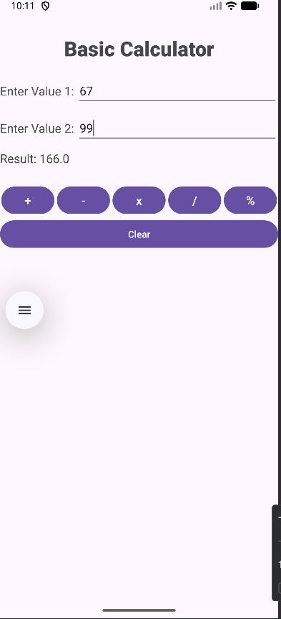

Result:
The basic calculator Android application was successfully developed and executed with correct arithmetic operations and output display.

